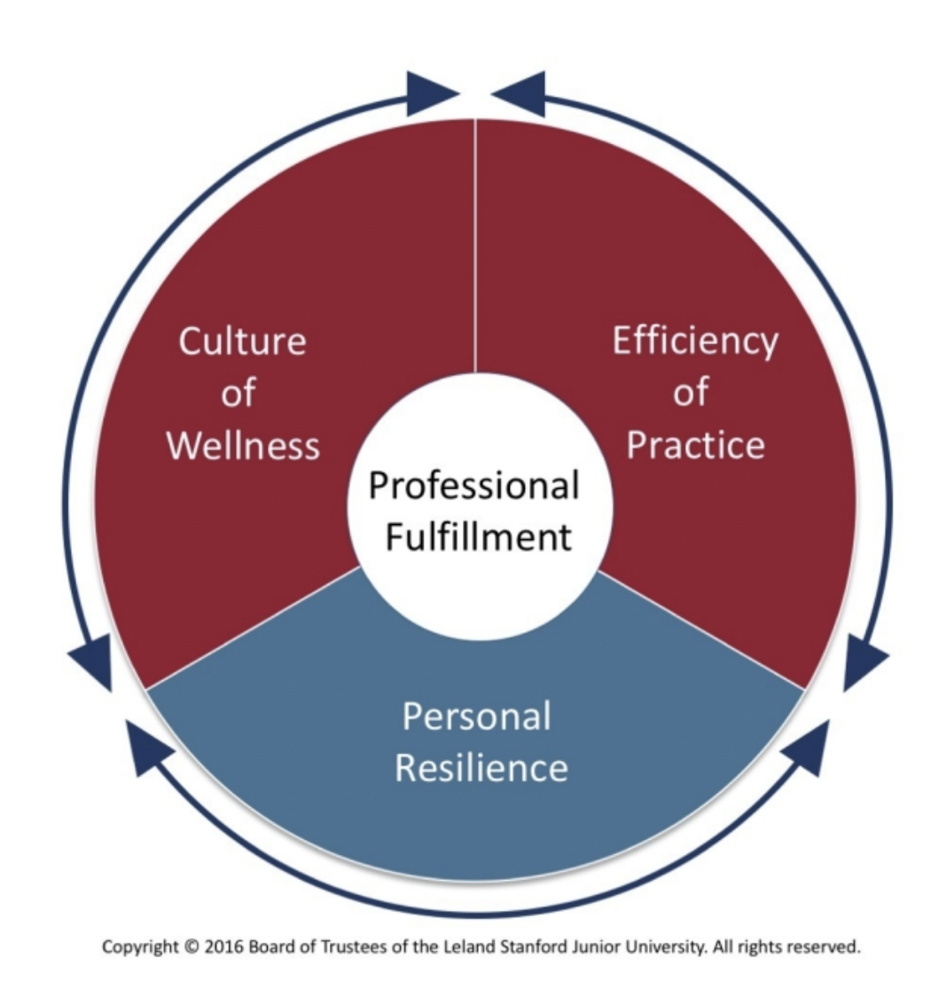

Figure 1 Image Source: https://wellmd.stanford.edu/about/model-external.html

Advertising/Awareness Plan:

Interventions/Action Plan:

- Culture:

- Efficiency of Practice:

- Personal Resilience:

