GEMS September 16, 2021, Meeting Minutes

Participants: Lauren Southerland, MD, FACEP; Maura Kennedy, MD; Phillip Magidson, MD; Kevin Biese, MD, MAT, FACEP; Stephen Meldon, MD, FACEP; Danya Khoujah, MBBS, MEHP; Rachel Skains, MD; Shan Liu, MD, FACEP; Katren Tyler, MD, FACEP; Luna Ragsdale MD, FACEP; Kyle Burton, MD; Christopher Carpenter, MD; Nicole Tidwell; Amber Hartman

- RESIDENT AND FELLOW ELECTION STATUS
  - Voting survey sent out on 9/21 and will close on October 4th. Four Resident candidates, 3 Fellow candidates. Will announce elected candidates at the section meeting occurring at ACEP21.

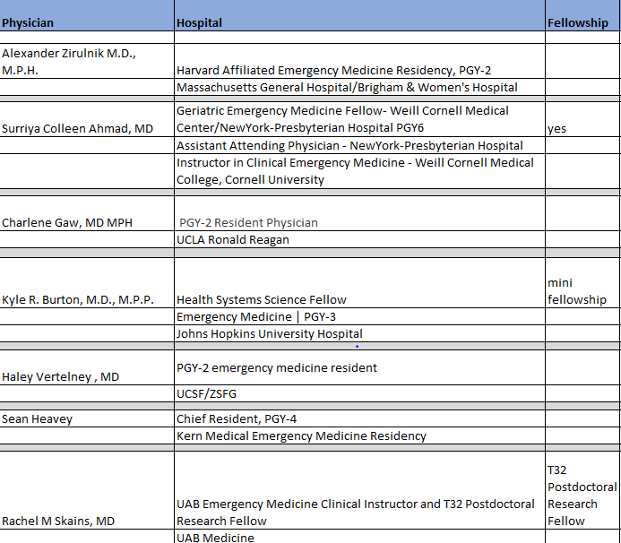

- ACEP21 SECTION MEETING: VIRTUAL Tuesday, October 26, 2021. 12:30 -2:00 EST – Nicole provided an overview of the agenda. GEMS section meeting will be virtual via Zoom. Nicole will keep the conference room that the section meeting would have been held in so in person attendees can gather and attend the virtually. Presenters will not be presenting in the conference room, virtual presentations only. Nicole to look into small refreshments for in person attendees. Nicole will try to have a compilation of highlights from the GEDA pre-con ready for section meeting.
AGENDA:

- Introduction of board, new positions (President, resident, fellow)
Maura Kennedy, MD, MPH Lauren Southerland, MD, FACEP 12:30 (10 min)
- Ice breaker and group introductions 12:40 (10 min)
Dr. Kennedy and Dr. Southerland to come up with ice breaker.
- JACEP Open Access 12:50 (5min)
Henry Wang, MD, MS,FACP
- Updates on GED projects and opportunities 12:55 (10 min)
JGEM/ GEDC
Teresita Hogan, MD, FACEP; Kevin Biese, MD, FACEP, MAT
- Geriatric ED Guidelines 1:05 (10 min)
Shan Liu, MD, FACEP
- Geriatric “Boxing” Match 1:15 (35 min?)
Let’s Debate!
GEMS members, geriatric fellows
- GEDA Update 1:50 (10 min)
Kevin Biese, MD, FACEP, MAT - Nicole to create a slide for GEDA Update
- Council Update 2:00 (10 min)
Shan Liu, MD, FACEP; Phil Magidson, MD, MPH
- Summary and conclusion 2:25 (10 min?)
- Possibly add “a year ahead” topic where participants can share what they think the GEMS section should be working on. Create time for feedback and considerations for moving forward with the next year.

Main event – a “boxing” event with speakers discussing a hot topic one speaker to discuss the pros and the other, the cons. If you have more ideas for topics or experts for the debate, please email Lauren. Nicole to create a poll for boxing match. Three topics decided on below:
a. Delirium with a questionable UA – Skains Con/Maura Pro as backup. Danya to create a video presenting the case study.
b. Telehealth – Kevin for pros/Lauren Cons
c. Admitting with delirium with no initial cause found – Maura Cons/Phil Pro admission. Maura and Lauren to write the case study. Case study should be as concrete as possible.

*Council meeting will be in person.

- ACEP22 DIDACTICS-
  - Due November 7th. Need to increase the amount of geriatric content. Nicole, Maura, Lauren and Danya to meet to review previous content submission. Focus on topics that could cover more than one track, such as Beyond the B52, pain management in older adults and resuscitation.

- ACEP21 GERIATRIC PRE-CONFERENCE VIRTUAL / The 4Ms and Geriatric Emergency Care
Date: Sunday, October 24, 2021; 3.5 hours (210 Mins)
Price: ACEP Member Price $54 / RN Price $54 /Non-Member Price $98

Time Allotted | Section | Details
50 minutes | Introduction | Deploying Geriatric Emergency Care Innovations across your state or health care system  Introductions:  - GEDA intro - 5 min pre-recorded (Rosenberg)  - AFHS intro - 5 min pre-recorded (JAH, Terry Fulmer)  - GED sustainability - 5 minutes (West Health, Shelley Lyford)  Key notes: - pursing GEDA/AFHS certification across a system and state  - Chad Kessler - to discuss VA system, virtual (20 minutes)  - West Health- California (15 minutes, Zia Agha)
60 minutes | 4M Education | - Mentation: Beyond the B52: understanding geriatric agitation - Maura Kennedy MD (12 minutes)  - Medication: Top Tips around Medication Safety in Older Adults - Jenny Koehl, PharmD (12 minutes)  - Mobility: Assessing physical functioning and ensuring patient safety in the ED - Vanessa Delheim, PT (12 minutes)  - Matters: “What Matters” beyond the MOLST (12 minutes) - Kevin Biese  Questions (10 minutes)
75 minutes | 4M programs in action | - Video compilation of programs - 15 minutes  - Mentation: Stephen Meldon - implementing 4AT delirium screening across a health system - confirmed VIRTUAL pre-recorded and dial in for Q&A (15 minutes)  - Medications - Dartmouth tele-pharmacy - Suzy (15 minutes)  - Mobility : Liz Goldberg, GAPCare - confirmed (15 minutes)  - Matters: Don Melady- MAUVE - volunteers in the ED - confirmed (15 minutes)
15 minutes | Q&A | - Panelists from introduction and 4M programs in action
10 minutes | Conclusion | - Next steps (Lesser)  - GEDC systems initiatives  - Making the case  - Next steps  - Resources

- ACEP21 GEDA Pre-Con – Still need video submissions to create a compilation on the four Ms. Would like to have level three sites submit videos. Luna will follow up with the VA sites for possible video submissions.

