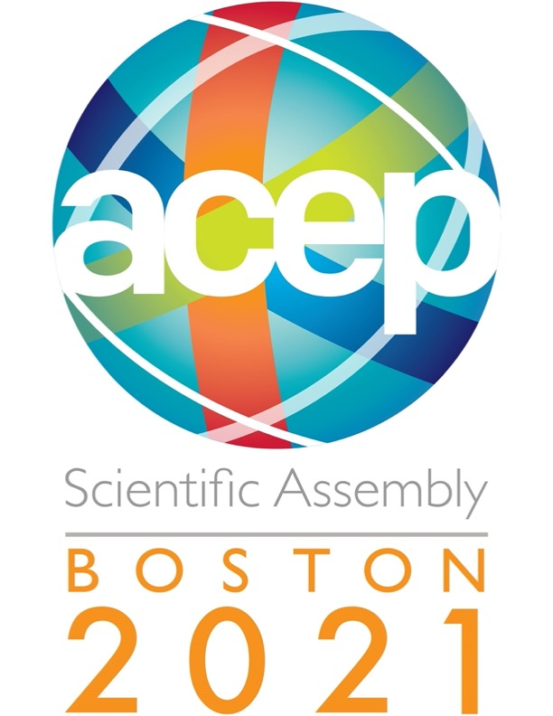
ACEP21 GEMS Meeting Minutes
Tuesday, October 26, 2021: 12:30 -2:00 EST

- Introduction of board and new positions (President, resident, fellow)
Lauren Southerland, MD, FACEP
- In-coming President: Maura Kennedy, MD, MPH (ACEP22)
- Secretary: Luna Ragsdale, MD, FACEP
- Councillor: Shan Liu, MD, FACEP
- Alternate Councillor: Phil Magdison, MD
- New Section Leadership Positions:
  - Haley Vertelney, MD- Resident
  - Rachel Skains, MD- Fellow
- Geri EM Journal Club every quarter – next meeting is November 4th!
- GeriEM Preconference 2021, 104 attendees attended 3.5- hour 4M discussion
- GEMs Newsletters – highlighting GEMs members, next one scheduled for 2022.
- Educational webinars conducted this year – “Geriatric Friendly Order Sets”
- Geriatric CME Track at ACEP21!
- GEMs member on educational board – Danya Khoujah
- New GED Book: Creating a Geriatric Emergency Department (cambridge.org) – Practical Guide to Creating a Geriatric Emergency Department

- JACEP Open Access - Henry Wang, MD, MS,FACEP
-Published over 10 papers related to geriatrics
-Fast turnaround time: 17 days to decision and <30 days to publication
-Mentorship program available
-In press for two years
-Unique opportunity to share your best science
-If interested in reviewing, send email to Maura Kennedy
-Check out the journal: jacepopen.com, contact the journal: jacepopen@acep.org

- Geriatric ED Guidelines Update - Shan Liu, MD, FACEP
-Proposed Guidelines 2.0 using GRADE
-Rolling guideline release
-1st topic: Delirium
- Who should be screened?
- How to identify?
- Head CT and delirium
-Other topics:
- Geriatric screening for at risk elders: Lisa Wolf
- Dementia guidelines: contact thogan@medicine.bsd.uchicago.edu
- Medication Safety: contact rskains@uabmc.edu
- Falls assessment and management: Lauren Southerland
- Palliative Care
- Elder abuse: webinar https://gedcollaborative.com/event/elder-abuse-and-neglect/
- If interested email sliu1@mgh.harvard.edu

- Council Update - Shan Liu, MD, FACEP; Phil Magidson, MD, MPH
-Votes every year on resolutions, elect president elect, vice president, board members
-Approximately 430 councilors voting on 82 resolutions
-General themes
- EM workforce – 10000 surplus EM docs by 2030
- NP PA staffing relationships – marketing campaign, policies
- Residency growth
- Diversity – speakers from diverse backgrounds with more content related to diversity
- Opiates – e.g., support for take home naloxone
-Geriatric topics
1% ACEP budget from GEDA
77 new accredited EDs past year
Resolution that only ABEM/ABOEM providers be medical experts on hyperactive delirium with severe agitation in out of ED settings

- GEDC Update - Kevin Biese, MD, FACEP, MAT
-GEDC Resource Page: https://gedcollaborative.com/resources/
-How to join implementation: email Kevin Biese
-How to join research: email Ula Hwang; gearnetwork.org
-Geri EM efforts: GEAR. Guidelines, GEMs, GEDA sits in ACEP
-Learning collaborative, leading experts convene and together work with hospitals around the world to make it better
Boot camps all over the world (city, county, hospital systems) , webinars
-51 GEDC Member Sites
-279 Accredited GEDA Sites
-GEDC and GEDA are different entities
-Research arm led by Ula Hwang
-Two parts:
1) based at Yale and closely connected with GEAR (funded arm through NIA) – attempt to make the case that GEDs make a difference, working with West Health support
2) Implementation arm out of UNC – spreading best practices
-If you have a Geri ED project that you’re excited about and want to write an informal <400-word blog post about it — send it to don.melady@utoronto.ca

- Updates on GED projects and opportunities - JGEM/Teresita Hogan, MD, FACEP
https://gedcollaborative.com/resources/journal-of-geriatric-emergency-emedicine/
can get links through GEDC as well
It is its own specific subspecialty
Email Tess Hogan to be a peer reviewer thogan@medicine.bsd.uchicago.edu
- Geriatric “Boxing” Match
Let’s Debate!
GEMS members, geriatric fellows
- Should your GED set up telehealth for older adults?
  - Pro – our patients cannot afford us not to explore this option, move the information and not the patient, covid pronounced the need for this; telehealth needs to be happening and reality has not changed that bringing all sick people into the same place where some people do not need to be there. Bringing together expert panel – tracking data, age, demographics, SES and outcomes
  - Cons – using telehealth to make everything better, are you doing tele triage or post ED visit? Telehealth triage is not great, tons of barriers to telehealth – it only benefits who have good access, 1 out 4 adults 50-80 can see or hear enough to d telehealth, 1 out of 3 is not interested (social interaction); big SES divide – people who navigate technology well may be more ready to use telehealth
- Should you give antibiotics for a patient with delirium and a questionable UA
  - Pros
    - UA not sensitive
    - UTIs are most common of sepsis
    - Low risk
  - Cons
    - ASB
    - Potential complications from treating with abx and possible premature closure
    - Urine Testing and UTIs in the Older ED Patient - CanadiEM
    - AGS also does not support use of abx in older patients without urinary symptoms
- Should you admit the patient with mild to moderate delirium and no cause found on thorough ED evaluation
  - Pros – Admit
    - Caregivers know best
    - Deliberate Clinical Inertia
    - Prevent death, reduce costs, believer in your work
  - Cons
    - Mattison et al best practices
    - Non pharm
      - Mobility, normalize routine
    - Pharm
      - No medications

- GEDA Update - Kevin Biese, MD, FACEP, MAT
Interested in being a GEDA reviewer? Email Ntidwell@acep.org
2 million patient visits in GEDAs--we have changed the standard of care!

- Consideration for GEMS
-Newsletter ideas? Highlight programs and also with videos.
-More webinars?
-Referendum to council?? Boarding in the ED for SNF placement
-ACEP NOW – 1 to 2 articles published in this journal?
-ACEP GEMs awards to honor innovation – ACEP GEM innovation awards for community sites?
-Translating GEM research at academic centers to rural community sites without resources – Monthly meeting on this?

Email Lauren lauren.southerland@osumc.edu or Maura Kennedy at mkeendy8@partners.org

- Educational ideas for ACEP 2022: social inequities among older adults and addressing SDOH in this population
-Developing plug and play epic workflows
-Clinical Innovation Awards Process group?? – Katren is interested in being a part, Shan is also interested; identify a program
-Separate award for promoting GED work – John A Harford
-SAEM has a series of awards – combine the awards with SAEM? SAEM is more research based.
-At the VA, Urgent cares want to onboard geriatric friendly practices

