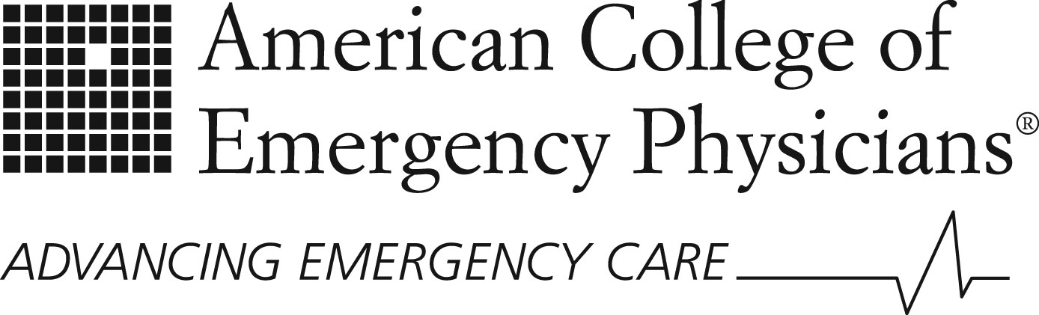 | Policy  Statement

Approved January 2016 | Advanced Life Support Courses

Revised January 2016  Revised February 2009  with current title  Originally approved October 2002 as Council Resolution CR29 titled “American Heart Association ACLS Course" |  | The American College of Emergency Physicians (ACEP) believes that education and instructional tools, such as Advanced Cardiac Life Support (ACLS), Pediatric Advanced Life Support (PALS), Advanced Pediatric Life Support (APLS), Advanced Trauma Life Support (ATLS), Comprehensive Advanced Life Support (CALS) and other similar courses are guidelines that are used as educational tools. They should not be interpreted as standards of care. Furthermore, the content of the guidelines may not be appropriate for an individual patient; therefore the guidelines should not be used to direct or standardize the actions of emergency providers.

