Welcome to XXXXXXX Hospital.
Based upon your symptoms, we are placing you in a special patient care room.
Please keep the door closed at all times and remain in the room at all times.
If you were provided a mask, please keep it on.
In order to contact staff you can either use the nurse call bell button (picture below) or the phone mounted on the wall (if you call XXX you will be put through to the nursing station in the Emergency Department).
If the phone in your room rings, please answer it. We may contact you to get additional information.
At this time, we ask that you avoid having visitors. If you require a visitor, they must remain in the room with you at all times.
We are happy to take care of you and are taking these precautions in order to protect you, your friends and family, and the staff that are caring for you.
Thank you!!!
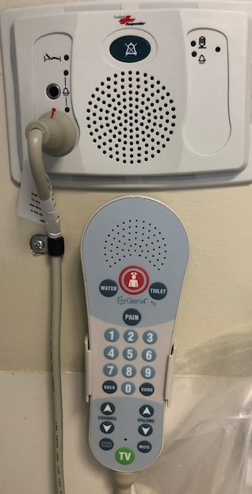
Nurse call bell button; press to communicate with the main nursing station in the Emergency Department

